**DAILY ONLINE ACTIVITIES SUMMARY**

|  |  |  |  |  |  |  |  |
| --- | --- | --- | --- | --- | --- | --- | --- |
| **Date:** | **16-06-2020** | | | | **Name:** | **B.A.SOHANKUMAR** | |
| **Sem & Sec** | **4TH SEM A** | | | | **USN:** | **4AL18CS013** | |
| **Online Test Summary** | | | | | | | |
| **Subject** | | **COMPLEX ANALYSIS, PROBABILITY AND STATISTICAL METHOD** | | | | | |
| **Max. Marks** | | **30** | | **Score** | | **24** | |
| **Certification Course Summary** | | | | | | | |
| **Course** | **MACHINE LEARNING FOUNDATIONS** | | | | | | |
| **Certificate Provider** | | | **GLA** | **Duration** | | | **6 HOURS** |
| **Coding Challenges** | | | | | | | |
| **Problem Statement: Write a c program to implement the binary reversal.** | | | | | | | |
| **Status:EXECUTED** | | | | | | | |
| **Uploaded the report in Github** | | | | **YES** | | | |
| **If yes Repository name** | | | | **LOCKDOWN CODING** | | | |
| **Uploaded the report in slack** | | | | **YES** | | | |

**ONLINE TEST DETAILS:**

Today online test was on the 1st module of COMPLEX ANALYSIS, PROBABILITY AND STATISTICAL METHOD (18MAT41).The duration of the test was 40 minutes from 03.00pm to 03.40pm.Questions were of multiple type and score I received is 24/30.

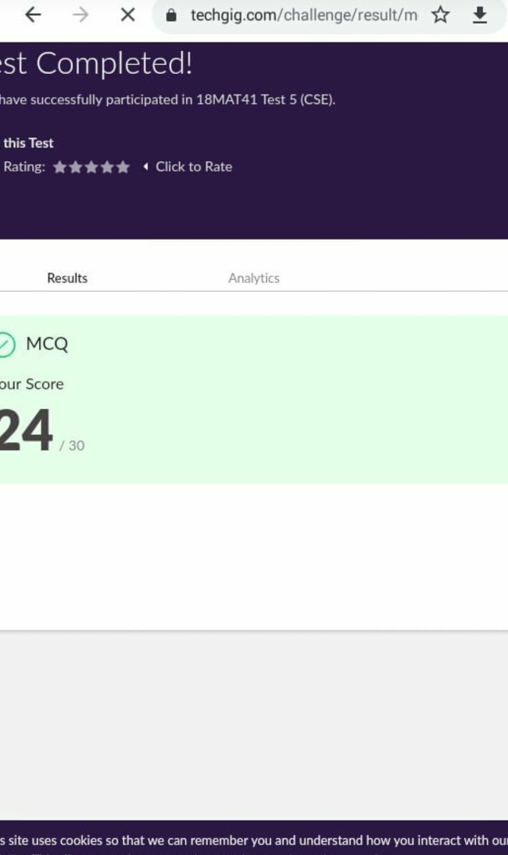

**CERTIFICATION COURSE DETAILS:**

Course:Machine learning foundations

Today I have opted this new course and completed the following topics How much of maths is required for data science-3,Line Concept-3,Lines_Planes and Hyperplanes-3,Vector algebra_Magnitude and direction-3,Vector algebra_Vector Operations-3,Vector lab exercises-3,Matrices-3,Basic_Algebra.ipynb,Introduction to Functions-3,Differential of a function-3,Maxima and Minima of a function-3,Chain Rule-3,Maxima and Minima application in machine learning-3.

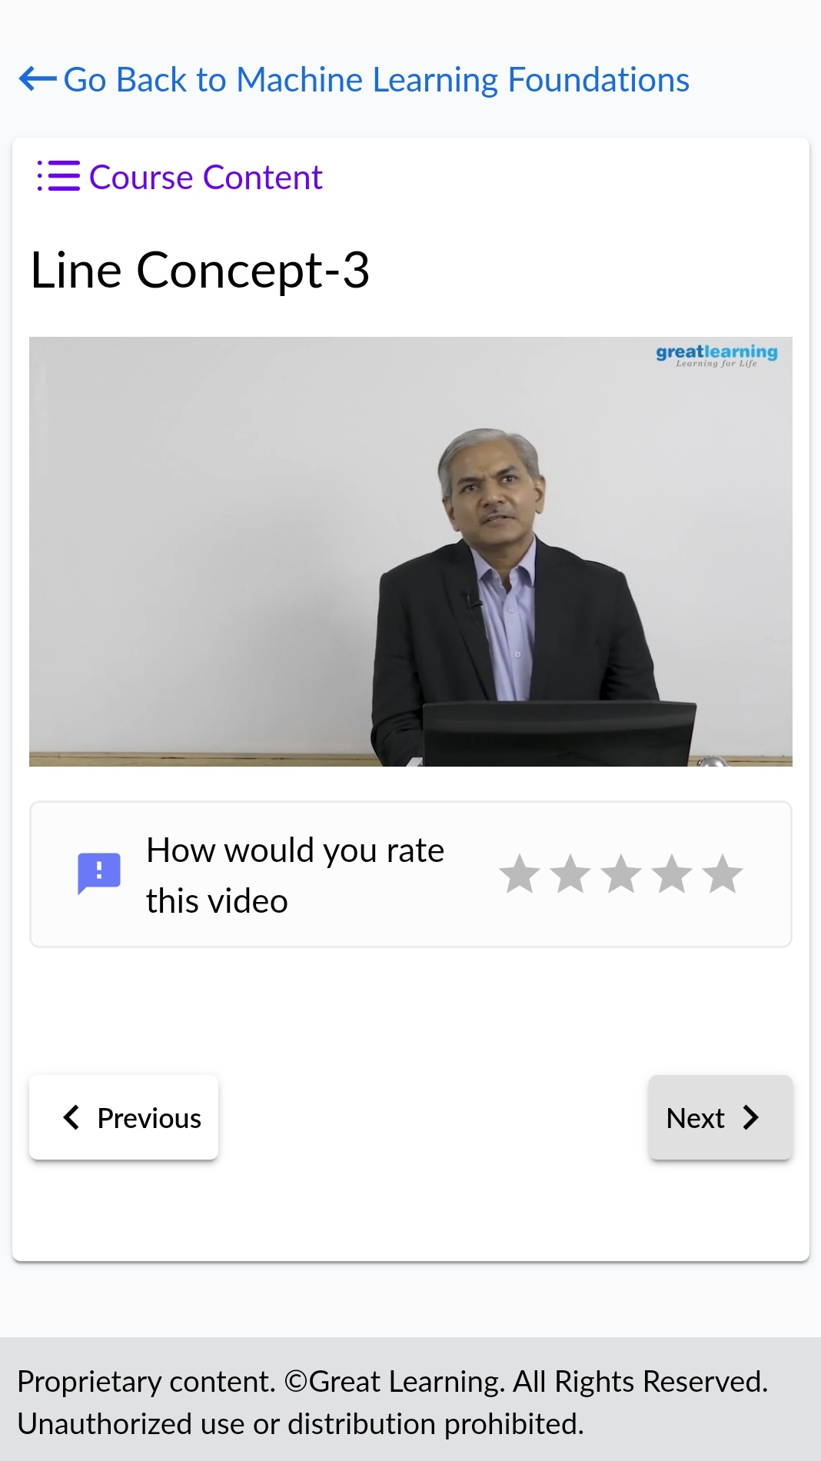

Participated in equiz on" OPERATING SYSTEM" organised by Department of computer science and engineering in moodalkatte institute and technology.Duration of equiz was 20 minutes and successfully completed the quiz at 90% and the certificate was awarded.

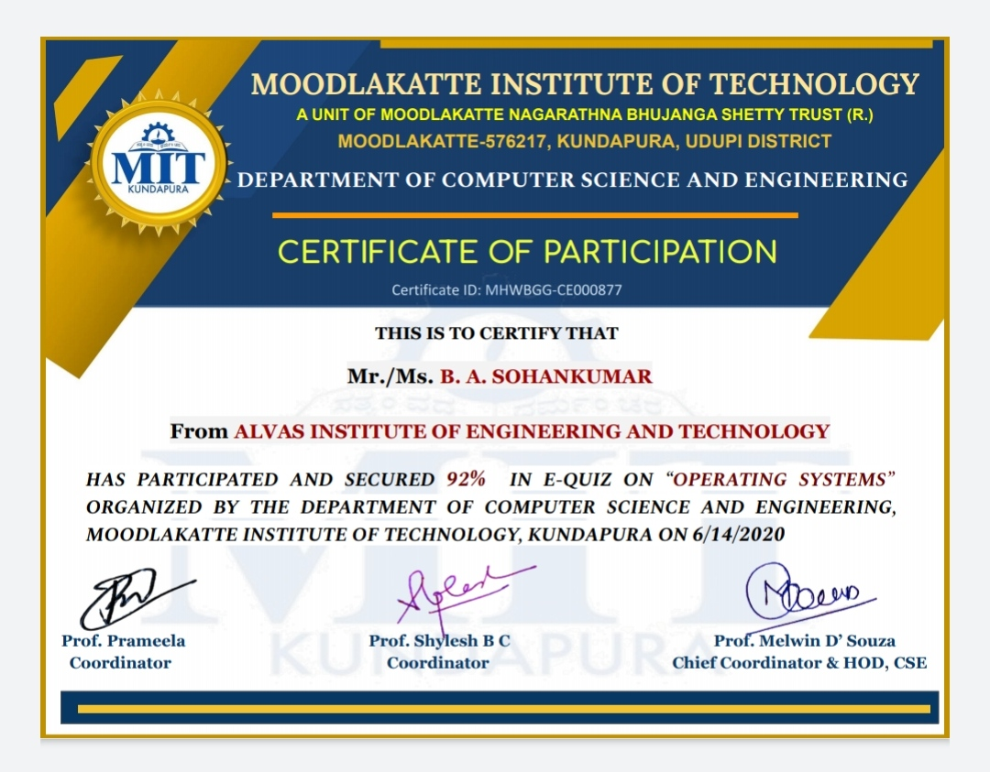

**CODING CHALLENGES:**

1.Write a C program to implement the binary reversal.Have the function BinaryReversal(str) take the str parameter being passed, which will be a positive integer, take its binary representation, reverse that string of bits, and then finally return the new reversed string in decimal form. For example: if str is 47 then the binary version of this integer is 101111 but we pad it to be 00101111 (Total number of bits must be multiples of 4). Your program should reverse this binary string which then becomes: 11110100 and then finally return the decimal version of this string, which is 244.

Examples:Input: 213 Output: 171

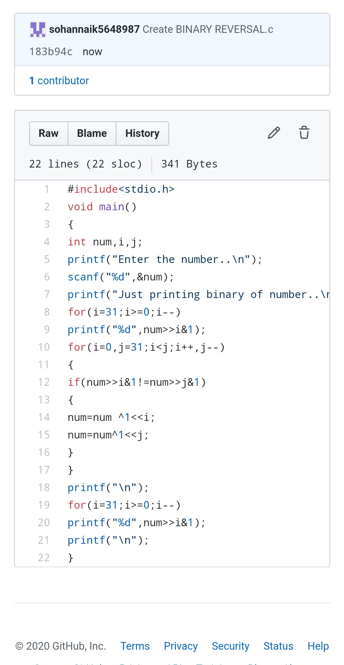

REPOSITORY LINK:https://github.com/sohannaik5648987/C-CODING